**ANKIT JAIN**

**20178009**

**OPERATING SYSTEMS LAB 2019**

**Assignment**

**// Myls command**

The following steps were performed:

1. Code of ls was copied in a file named myls.c
2. Added an entry of myls in the makefile
3. Executed the command successfully myls on qemu.

**Screenshot of the Output :-**

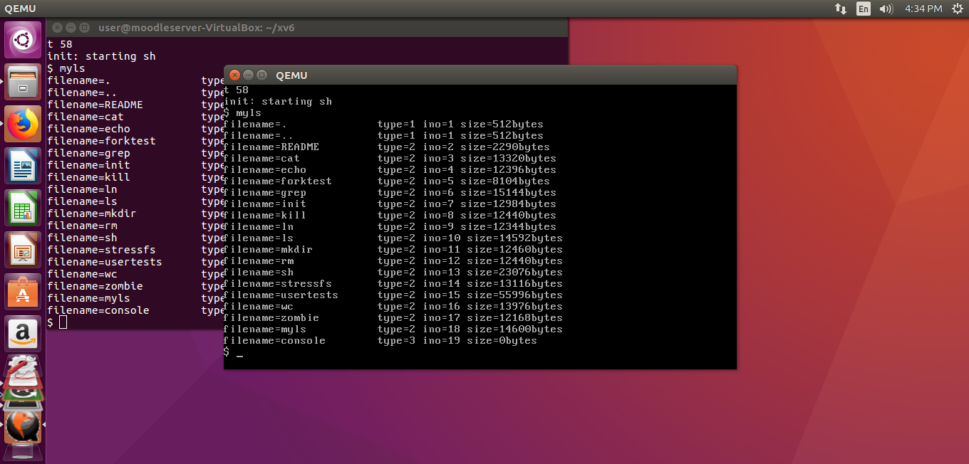

**// Adding ps system call**

The following steps were performed:

1. The steps in ppt were performed.
2. The changes were made in makefile by adding the entry of ps.
3. The changes were made in proc.c and ps.c to count the running and sleeping process.
4. Executed the command ps successfully on qemu.

**Screenshot of the output :-**

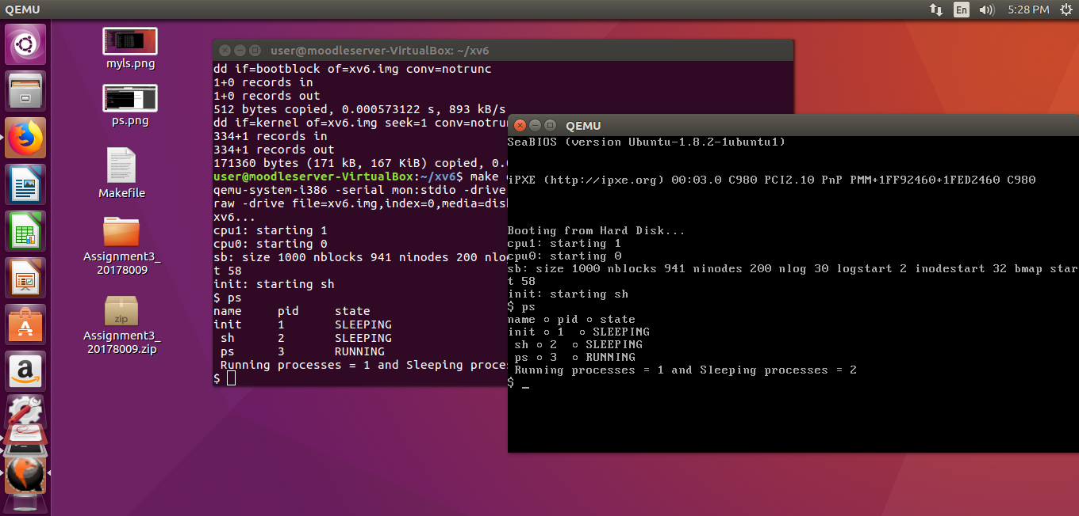

**The files which are also included in zipped folder :-**

1. **proc.c**
2. **ps.c**
3. **Makefile**